**Software Engineering Semester 2**

**MEDIA BAZAAR**

**Test Report**

October 2020

S-CB-S2-CMK Group 3



Table of Contents

TC-01: 3

TC-02: 3

TC-03 4

TC-04 4

**TC-05** 4

Tc-06 5

Tc-07: 5

**TC-08:** 5

TC-09: 5

General Note: 6

# TC-01:

Unsuccessful when using given test data.

We typed in correct data system gives error (Input string in incorrect format) first and then logs in

Note: Logging in doesn’t work sometimes and no message is passed.

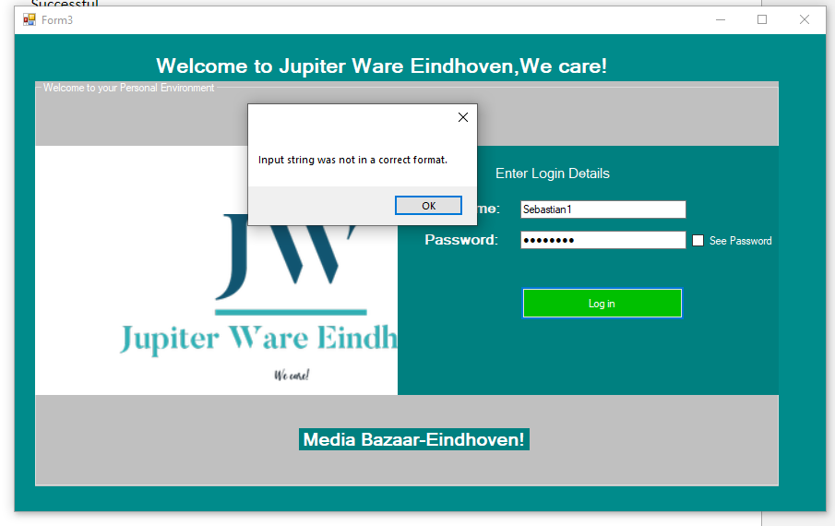

# TC-02:

Unsuccessful

No error message: System does not notify user about wrong password or username

# TC-03

Successful

But it only showed the DataGrid view with no data in it.

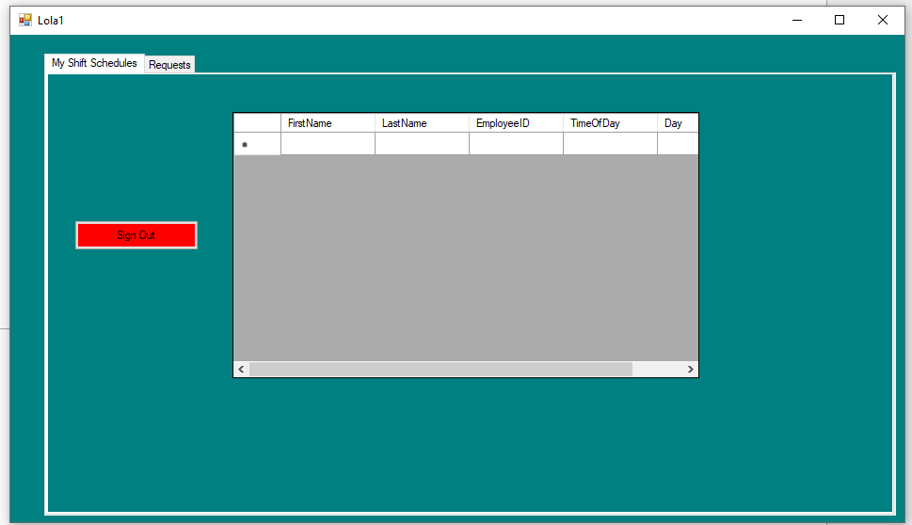

# TC-04

Unsuccessful

With the given user login, we couldn’t get to an attendance form. If there is a form for attendance, then it is not clear to a user how to get there.

# **TC-05**

Unsuccessful

We didn't know which button to press to get to the expected result which makes it unclear.

# Tc-06

Unsuccessful

It gets a notification that the restock request has been sent even without any values inputted.

And no information about a restock request is seen in the admin form.

# Tc-07:

Successful

Note: the admin should not be given the ability to add an employee ID this should be auto generated

# **TC-08:**

Successful

# TC-09:

Unsuccessful

We had to use the employee Id to assign shifts and not the employee name, which means the instructions weren't valid.

# General Note:

The system gives an error after few SQL operations have occurred

